Solution to every third end-of-chapter problem
Basics of Engineering Economy, 2nd edition
Leland Blank and Anthony Tarquin

Chapter 12
Depreciation Methods

12.1 Depreciation is a tax-allowed deduction in the equation Taxes = (income –
expenses – depreciation)(tax rate)

12.4 Productive life – Time the asset is actually expected to provide useful service.
Tax recovery period – Time allowed by tax laws to depreciate the asset’s value to salvage (or zero).
Book recovery period – Time used on company accounting books for depreciation to salvage (or zero)

12.7 Tax depreciation: D_{t} = Rate(BV_{t-1})
Book depreciation: D_{t} = Rate(40,000)

 | Tax Depreciation |  | Book Depreciation
Year, t | D_{t} | BV_{t} | D_{t} | BV_{t}
0 |  | 40,000 |  | 40,000
1 | 16,000 | 24,000 | 10,000 | 30,000
2 | 9,600 | 14,400 | 10,000 | 20,000
3 | 5,760 | 8,640 | 10,000 | 10,000
4 | 3,456 | 5,184 | 10,000 | 0

Spreadsheet solution with graphs follows.

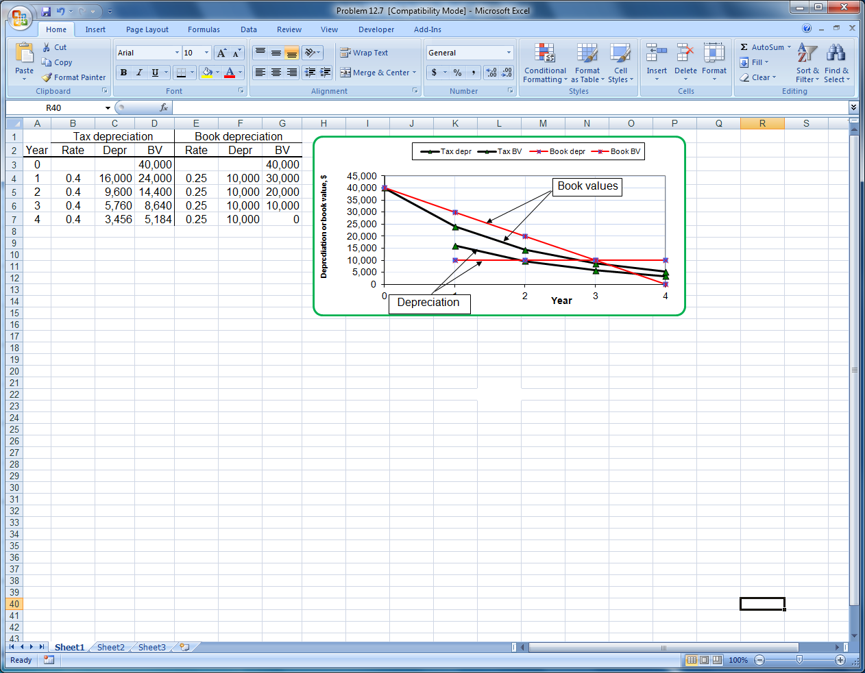

12.10 (a) Depreciation charge is determined from the change in book value

D = 296,000 - 224,000 = 72,000/year

Since the asset has a 5-year life 2 more years of depreciation will reduce BV to salvage value.

S = 224,000 – 2(72,000) = $80,000

(b) (B – 80,000)/5 = 72,000
B = $440,000

12.13 Spreadsheet solution uses SL depreciation.

D_{t} = (350,000 – 50,000)/5 = $60,000 per year

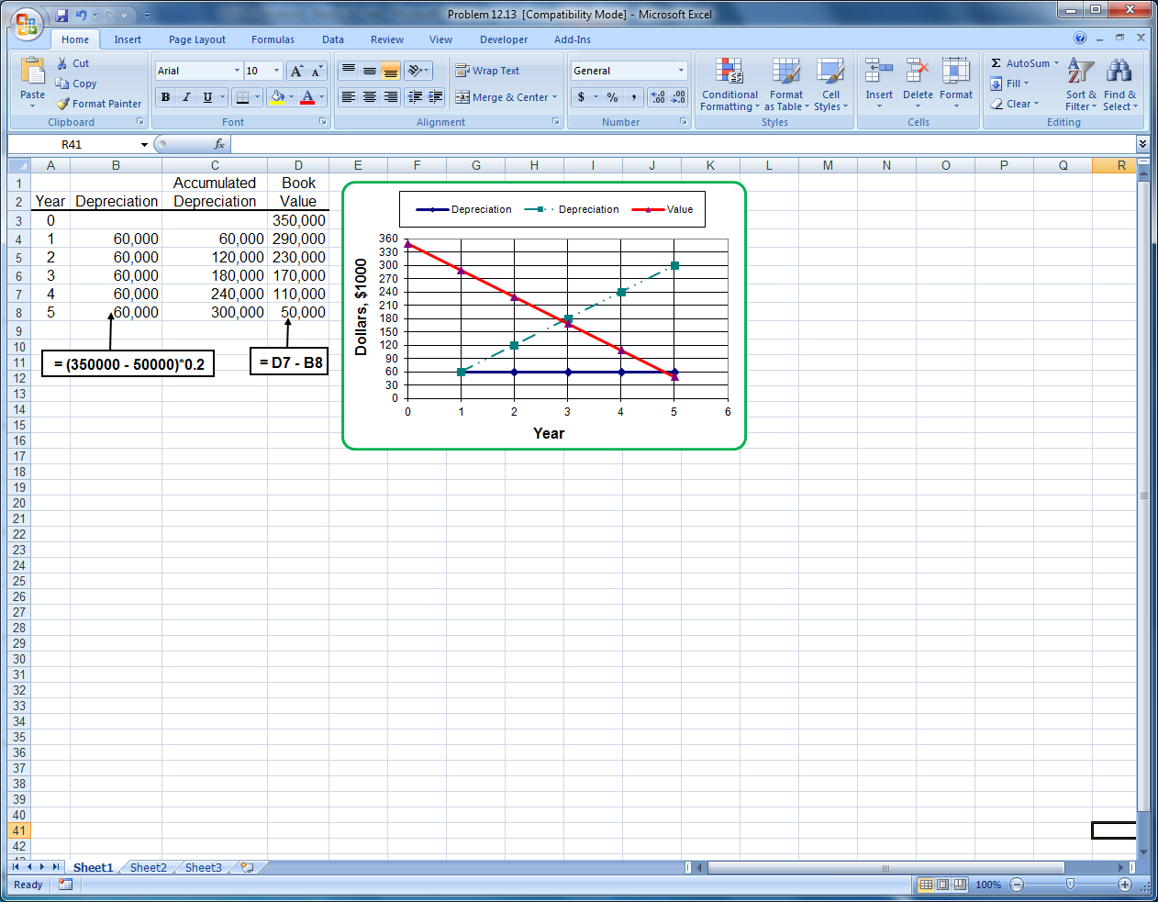

12.16 Substitute 0.25B for BV. Depreciation rate is d = 2/5 = 0.4

0.25B = B(1 – 0.4)^{t}
log 0.25 = t(log 0.6)
t = 2.71years

Salvage value will be reached by end of 3rd year

12.19 (a) SL: BV₁₀ = $10,000 by definition

DDB: Use Equation [12.9] to determine if the implied S < $10,000
with d = 2/7 = 0.2857
BV₁₀ = BV₇ = B(1-d)⁷ = 100,000(0.7143)⁷
= $9486

Both salvages are less than the market value of $12,500

(b) SL: D₁₀ = (100,000 - 12,500)/10 = $8750
DDB: D₁₀ = 0, since n = 7 years

A spreadsheet solution for both parts follows.

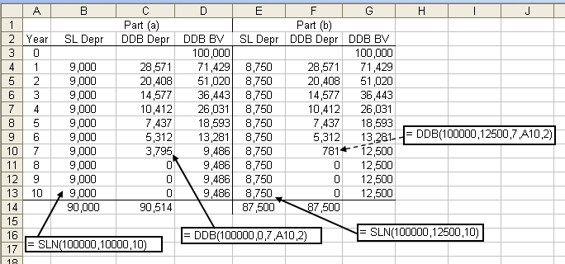

12.22 BV₃ = 400,000 - 400,000(0.20 + 0.32 + 0.192)
= $115,200

12.25 SL: D₄ = [80,000 - 0.25(80,000)]/5
= $12,000 per year

BV₄ = 80,000 – 4(12,000)
= $32,000

MACRS: BV₄ = 80,000 – 80,000(0.20 + 0.32 + 0.192 + 0.1152)
= $13,824

Difference = 32,000 – 13,824 = $18,176

MACRS has a lower BV after 4 years

12.28 MACRS: D₁ = 0.01391(3,400,000) = $47,294
D₂ to D₁₀ = 0.02564(3,400,000) = $87,176

Total depreciation for 10 years = 47,294 + 9(87,176) = $831,878
BV₁₀ = 3,400,000 – 831,878 = $2,568,122

Anticipated selling price is 1.5(BV₁₀) = $3,852,183

Fairfield hopes to sell it for $452,183, or 13.3%, more than they paid for it.

12.31 d = 1/5 = 0.20, For year 2, by DB method

DB : D₂ = 0.20(100,000)(1 – 0.20)¹ = $16,000

For SL method, need BV₁ from DB method with d = 0.20

BV₁ = 100,000(1 – 0.2)¹ = $80,000

New SL depreciation

D₂ = (80,000 – 10,000)/4 = $17,500

SL has larger depreciation by 17,500 – 16,000 = $1500; switch to SL is advisable

12.34 Verify the following MACRS rates using the modified DDB-to-SL switching.

t 1 2 3 4 5 6__
d_{t} 0.20 0.32 0.192 0.1152 0.1152 0.0576

The DDB rate to start is d = 2/5 = 0.40.

d₁: DDB: d₁ = ½d = 0.20

d₂: Accumulated depreciation = Accumulated D = 0.20

DDB: By Equation [12.14]

d₂ = 0.4(1 – 0.2) = 0.32 (selected)

SL: Modify Equation [12.15] to have denominator (n-t+1.5)

d₂ = 0.8/(5-2+1.5) = 0.8/4.5 = 0.178

d₃: Accumulated D = 0.2 + 0.32 = 0.52

DDB: d₃ = 0.4(1 – 0.52) = 0.192 (selected)

SL: d₃ = 0.48/(5-3+1.5) = 0.137

d₄: Accumulated D = 0.2 + 0.32 + 0.192 = 0.712

DDB: d₄ = 0.4(1 – 0.712) = 0.1152

SL: d₄ = 0.288/2.5 = 0.1152 (select either)

Switch to SL occurs in year 4.

d₅: Use the SL rate for n = 5

Accumulated D = 0.2 + 0.32 + 0.192+ 0.1152 = 0.8272

SL: d₅ = 0.1728/(5-5+1.5) = 0.1728/1.5 = 0.1152

d₆: d₆ is the remainder or 1/2 the d₅ rate. Accumulated D = 0.9424

d₆ = d₅ /2 = 0.0576
or
d₆ = 1 – 0.9424 = 0.0576

12.37 Income = 6000(6) + 7000(9) = $99,000

Percentage depletion charge = 99,000(0.05) = $4950

12.40 (a) Determine the cost depletion factor in $/1000 tons and multiply by yearly
tonnage.
p_{t} = 2,900,000/100 = $29,000 per 1000 tons

Annual cost depletion = volume × $29,000

Year | Volume,  1000 tons | Cost depletion,  $ per year
1 | 10 | 290,000
2 | 12 | 348,000
3 | 15 | 435,000
4 | 15 | 435,000
5 | 18 | 522,000
Total | 70 | $2,030,000

(b) Cost depletion is limited by the total first cost, which is $2.9 million. Since
only $2.03M has been depleted, all 5 years’ depletion is acceptable.

12.43 Depreciation is same for all years in straight line method.

D₃ = [100,000 – 0.20(100,000)]/5 = $16,000

Answer is (a)

12.46 d = 2/5 = 0.4
BV₂ = 30,000(1 – 0.4)² = $10,800

Answer is (b)

12.49 Salvage value is always $0 for the MACRS method.

Answer is (a)

12.52 Percentage: GI = 65,000(40) = $2.6 million
Depletion charge = 0.05(2.6 million)
= $130,000

Cost: p_{t} = $1.28 per ton
Depletion charge = (65,000)(1.28)
= $83,200

Answer is (b)

